**Sequencing the delta smelt genome: improved annual monitoring of Ne and further understanding of the wild and hatchery delta smelt populations**

June 30, 2020 Annual Report

Shannon E.K. Joslin, Ensieh Habibi, Mary Delaney, Justin Smith and Amanda J. Finger

University of California, Davis

This document will serve as the 2020 annual report for A19-1844 contract between State Water Contractors and the Regents of the University of California.

**Background**

For this project we are assembling a reference genome for delta smelt in order to 1) calculate a more precise estimation of contemporary effective population sizes (NE) for the 2017 to 2019 wild cohorts, 2) examine domestication selection at discrete locations in the genome, and 3) identify sex-specific markers and/or chromosomes in delta smelt. The creation of a reference genome for delta smelt will enable scientists to more fully take advantage of the decreasing samples available and use archival samples more effectively. All deliverable statuses are listed in Table 1.

The use of next generation sequencing (NGS) technologies in conjunction with a highly contiguous and accurate reference genome, increases the power and precision of inferences made in population genetic studies (such as structure, diversity, understanding local adaptation).1 DNA sequences unaligned to a reference genome fail to account for how each piece of sequenced DNA interacts with all other sequences (i.e. linkage patterns). However, by aligning to a reference genome we have knowledge of where each piece of sequenced DNA lies within the genome and relative to other sequenced DNA. Additionally, by knowing each markers distance from one another, and how it is or is not inherited with other markers we can survey a greater number of informative markers spread throughout the genome. This creates the ability to better answer questions involving demography, adaptation, fitness, and disease susceptibility.2,3 For example, previous work in Chinook salmon using the closely related rainbow trout reference genome found small amount of markers that were associated with runtime.4 In 2014, these markers were located next to a gap in the rainbow trout reference assembly. Reanalysis using a highly contiguous 2018 Chinook salmon reference genome found diagnostic markers located within the gap in the 2014 reference genome (Prince *et al.* unpublished).5 This example underscores how reference genomes can propel conservation research forward.

Recently, genome sequencing technologies have become both more cost effective and efficient. Hybrid assemblies, that is assemblies that use multiple NGS technologies, are the most reliable way to achieve a chromosome-scale hi-quality genome assembly. The Vertebrate Genomes Project, a consortium aimed towards developing an assembly pipeline and quality standards for genome assemblies of all vertebrates, established quality goal metrics for the continuity, completeness and accuracy of reference genomes6. Therefore, a main goal of this project is to develop a highly accurate chromosome-scale reference genome, hereafter called “reference genome”, using linked-read, long-read and hi-c chromatic conformation (Figure 1).

**Task 1: Genome assembly**

***Sample collection (Figure 1A)***

*Methods*

The first step in any genome assembly is to collect tissue for the extraction of high molecular weight (HMW) DNA, which is extracted DNA that is longer in length (>50 kilobases) than standard DNA extractions. Because all of the sequencing technologies utilize sequence fragments on the order of tens of thousands of base pairs long or rely on long range interactions throughout the genome, extracted DNA for generating a contiguous genome assembly must be sufficiently long. Due to the difficulties in getting sufficient quantity of HMW DNA we conducted three trips to sample tissue from fish at the FCCL (Table 2). At the start of this project long-read sequencing was costly and we sought to only incorporate the sequencing technology if absolutely necessary; because of this our first and second sampling trips sought to acquire enough tissue to provide sufficient quantity of HMW DNA for linked-read and hi-c sequencing. However, at the end of 2019 the price of long-read sequencing dropped dramatically and based on our results from trips 1 and 2, for trip #3 we sought to acquire enough tissue to sequence a single male fish with all three of the technologies and a female fish with the last long-read technology. On each occasion fish were euthanized according to the approved animal care protocols/standard operating procedures. Back muscle, internal organ and/or scale tissues were sampled onsite at the FCCL and cooled for transportation directly to the UC Davis Sequencing Center.

*Preliminary results*

On the first trip we sampled back muscle from three males and three females (Table 2). These samples were flash frozen using liquid nitrogen and transported on dry ice. While we obtained sufficient HMW DNA from females, none of the sampled male fish from this trip produced enough HMW DNA. Therefore, we returned to the FCCL on a second trip and selected larger males. Extraction lengths from these male fish were also insufficient. A decision to take a third trip was made due to the availability of a new fish tissue preservation method that uses additional tissue types (not just back muscle) and storage of samples in cooled propylene glycol rather than flash freezing in liquid nitrogen. On the third trip we sampled back muscle tissue, internal organs, and scales from a total of two males and two females. Additionally, because DNA can be fragmented in the freeze-thaw process, we hedged our bets for sampling on third trip by preserving half of all sampled tissues in propylene glycol at 4°C, and half with the protocol used on trip 1 and 2 (flash freezing with liquid nitrogen and transporting on dry ice) which was successful for female fish.

***Isolation of high molecular weight genomic DNA (Figure 1B)***

*Methods*

For all three sequencing types (linked-read, long-read and hi-c), HMW DNA is required. All of the HMW DNA extractions from the tissues taken from the FCCL occurred at the UC Davis Sequencing Center using the protocol described in Wasko et al. (2003)7. We acquired samples and extracted DNA from both sexes to examine sex determination in delta smelt, which is currently unknown. The size range of extracted DNA fragments were determined using a pulse field gel run at a low frequency, to not shear the DNA, for 24 hours. Physical sampling and extractions were repeated until the mean distribution of extraction lengths was 50kb or greater and there was sufficient quantity of HMW DNA to carry out the required sequencing technologies for each sex (Figure 2).

*Preliminary results*

Trip 1: DNA from one male (T1M03) and one female (T1F02) DNA was extracted from the first sampling (See Table 2 for fish identifications corresponding to trips). HMW DNA from the T1F02 had DNA fragments of sufficient length for sequencing (Figure 2A).

Trip 2: We performed two rounds of extractions on two different males (T2M02 and T2M03). Yet despite multiple attempts at extraction we did not obtain HMW DNA fragments of sufficient length (Figure 2B-D).

Trip 3: We performed two rounds of extractions on multiple different tissue types (Table 2). From these extractions we acquired DNA of sufficient length from flash frozen back muscle tissue from flash frozen back muscle tissue from one male (T03M02_BM_FF, Figure 2E) and flash frozen scales from one female (T3F02_SC, Figure 2F). We did not observe that storing tissue in propylene glycol had an effect on increasing the fragment length of extracted DNA (Figure 2E & F).

***Linked-read library prep & sequencing (Figure 1C)***

*Methods*

Once sufficient extracted fragments were acquired, genomic DNA was adjusted to a concentration of 0.91 ng/µl. We selected the 10X Genomics platform (<https://www.10xgenomics.com/technology/>) for our linked-read sequence data. 10X Genomics library preparation takes extracted HMW gDNA, shears the DNA into 50kb long segments, inserts each fragment into an oil coated gel emulsion bead (GEM), further shears DNA within each bead, and attaches unique barcodes to all DNA fragments within each GEM for identification post-sequencing. Whole genome sequencing libraries were prepared using Chromium Genome Library & Gel Bead Kit v.2 (10X Genomics, cat. 120258), Chromium Genome Chip Kit v.2 (10X Genomics, cat. 120257), Chromium i7 Multiplex Kit (10X Genomics, cat. 120262), and Chromium controller according to manufacturer’s instructions. After library preparation 1.14 ng of template gDNA was loaded on a Chromium Genome Chip and sequenced to roughly 80x coverage on an Illumina NovaSeq6000 150bp PE lane (Illumina, San Diego, CA).

*Preliminary results*

For the first year of this project we determined that the delta smelt genome is roughly 0.9Gb, and in the last year we prepared and sequenced the male library to ~80x coverage. We consider this successful for this step.

***Linked-read post-sequencing quality control (Figure 1C)***

*Methods*

After sequencing, bioinformatics quality control (QC) steps are necessary at multiple stages in the workflow of assembling of a reference genome. Immediate sources of error in sequencing data can result from sequenced DNA being contaminated with off-target DNA in the wet lab during preparation for sequencing, or biases in base calls from the sequencing machine. To QC for these two types of error, we conducted three computational quality control steps (kat hist, kat gcp and kat comp) using the software program KAT8. Each step splits sequencing data into sub-sequences of a given length, or k-mer, (where k is equal to a specified sequence length), and plots out frequencies, or comparisons, to visually inspect the data for quality issues. All bioinformatics work was conducted on the UC Davis farm compute cluster (the farm).

*Preliminary results*

*Linked-read QC step 1 (contamination):*

For the first QC step to detect potential contamination, within KAT, we used kat hist and observed the number of distinct k-mers at different frequencies for lengths 16, 21, 27 and 33. (Figure 3A-D) in the female sample and k-mers of length 19, 23, 27 and 31 (Figure 3E-H) in the male sample. Uncontaminated samples are expected to have a single peak with a lot of k-mers at a very low frequency due to sequencer errors.

*Linked read QC step 2 (contamination):*

The second QC contamination step looks for signs of contamination by plotting the proportion of the k-mer comprised of the G and C nucleotide against the frequency of the that k-mer in the sequencing data and the number of distinct k-mers for a given GC count vs. frequency. Contaminated samples are expected to have a non-normal distribution. For example, samples contaminated with bacteria will have more k-mers with GC counts above 50%. We plotted GC counts against the frequency of k-mers of length 16, 21, 27 and 33 in the female sequencing data (Figure 4A-D) and k-mers of length 19, 23, 27 and 31 in the male sequencing data.

*Linked read QC step 3 (sequencing bias).*

The third QC step (sequencing bias between forward (R1) and reverse (R2) sequences) plots the frequency of a given k-mer in each of the paired-end sequence data files. Sequencing bias in either of the two files would result in an irregular pattern in the number of distinct k-mers. We plotted the number of distinct k-mers at different frequencies for the R1 and R2 files against one another for k-mers of length 16, 21, 27 and 33 in the female sample (Figure 5A-D) and k-mers of length 19, 23, 27 and 31 in the male sample (Figure 5E-H).

In the past year we performed computational QC on the male sequencing data. We have included female plots to provide a comprehensive view of all quality metrics in the linked-read sequencing for this project. We observed single peaks for each histogram indicating contamination is unlikely (Figure 3A-H). All GC count frequency plots show a single peak of distinct k-mers, meaning there are no signs of bacterial or organelle contamination (Figure 4A-H). The number of distinct k-mers does not appear to be skewed indicating that the raw data does not appear to have major sources of sequencing bias (Figure 5A-H).

***Long-read library prep & sequencing (Figure 1C)***

*Methods*

The inclusion of long-read data dramatically assists in creating a more contiguous assembly by spanning repetitive elements and resolving chimeric sequences throughout the genome. Long-reads provide greater continuity of scaffolded contigs and resolving repetitive sequences within genome assemblies, because the reads (sequence fragments produced from the sequencer) are thousands rather than hundreds of base pairs long. Previously, long-read sequencing was both costly and had an error rate up to 10%. Within the past year, new PacBio HiFi chemistry has come out to dramatically reduce the number of errors from almost 10% to under 1%. Additionally, the price of PacBio long-read sequencing has dropped dramatically, making sequencing a male and female fish affordable for this project.

*Preliminary Results*

The UC Davis Sequencing Center carried out a library prep and subsequent sequencing for the male fish. The PacBio HiFi SMRTbell® Library (<https://www.pacb.com/>) was prepped following the SMRTbell Express Template Prep Kit 2.0 procedure. The UC Davis Sequencing Center used a Megaruptor to shear DNA to an average length of ~15kb. The input for the library prep was 5.6ug of DNA and the library was size selected to 11kb. Prepped DNA was run on a Sequel II machine for a total of 30 hours. We are currently waiting on sequencing data from the female sample. Acquiring the latter data has been substantially slowed due to the COVID-19 laboratory restrictions.

***Long-read post-sequencing QC (Figure 1C)***

*Methods and preliminary results*

Sequencing data stored in binary files were downloaded from Bioshare, the UC Davis Sequencing Center’s host service. We used CCS software’s (<https://github.com/PacificBiosciences/ccs>) statistical model on raw reads from male delta smelt to generate highly accurate consensus sequences with known base quality values and convert data to a fastq format for downstream analysis. A base quality value assigns a score to each letter of sequencing data to denote the level of confidence in each base called by the sequencer. Next, we will acquire sequence data from the female fish and perform the same QC steps on that sample.

***Long-read Draft Assembly (Figure 1D)***

*Methods and preliminary results*

After QC,an initial assembly with PacBio sequencing data strings together sequencing reads to create a draft assembly using the hicanu implementation of the canu version 2.0 software9 (preprint). This software processes reads to eliminate homopolymers (repeats of a single base pair) and then strings together reads with overlapping sequences. It then expands the sequences to include the information about the homopolymers and validates the assembly.

We created an initial draft assembly with our male long-read data using the hicanu implementation of canu version 2.0. Next we will process the female long-read sequence data similarly.

***Hi-C Chromatin Conformation Capture (Figure 1C)***

*Methods*

Genomic DNA in eukaryotes has high levels of repetition, leading to unresolved gaps surrounding large repetitive elements such as in the middle and at the ends of each chromosome. In order to resolve these gaps, we are using hi-c chromatin conformation capture (hi-c). We outsourced hi-c library prep and sequencing to Phase Genomics in Seattle, WA. Tissue from the same female that was sequenced with linked-read sequencing was sent to Phase Genomics for hi-c library prep and subsequent sequencing. Raw sequencing data and an initial scaffolding report were received for the female sample.

*Preliminary results*

At present we have downloaded the raw sequencing data and associated files from Phase Genomics’ Google drive. Initial reports from Phase Genomics indicate a successful library prep and sequencing. A total of 87,444,477 read pairs were analyzed of which 56.38% where high quality with a minimum mapping quality of greater than or equal to 20, a maximum edit distance of less than or equal to 5, and no duplications. The data contained an average of 2,966.33 read pairs per contig greater than 5kb. These data appear normal and indicate they will be useful in creating a more contiguous assembly.

Next Steps

*Male Assembly*

* Send male tissue sample out for hi-c library prep and sequencing
* Continue to develop assembly pipeline:
  + Assess quality of initial long-read assembly using BUSCO
  + Purge duplicate sequences from long-read assembly
  + Scaffold long-read assembly with linked-read data for male (Figure 1E)
  + Resolve major gaps in the assembly by incorporating hi-c data (Figure 1F-G)

*Female Assembly*

* Sequence female sampled on trip #3 with long-read technology (Figure 1C)
* Perform long-read assembly pipeline developed with male sample on the female sample (Figure 1A-G)

**Task 2: Estimation of Effective Population Size**

***DNA Sampling***

*Methods*

We received adipose fin clips of wild BY2019 cohort and they are currently stored at the GVL before extraction. DNA from fin clips of wild BY2017 were extracted using a Qiagen DNEasy kit. A RAD library was prepped for BY2017 following the Best RAD protocol described in Ali et al (2016)10.

*Preliminary results*

We have not yet performed analyses to estimate NE for these data.

Next Steps

* RAD library prep for BY2018 and BY2019
* RAD sequence BY2018 and BY2019 cohorts.
* Estimate effective population size across all birth years.

**Task 3: Examining domestication selection**

*Background*

Previously, we reported some results based on an early RAD assembly where we sequenced four groups of delta smelt with varying levels of domestication (DI): wild, low, medium, and high DI. Since then we have produced a linked-read draft assembly that is orders of magnitude more contiguous than the previous RAD sequencing derived assembly. During the past year, we reanalyzed our sequencing data using the new draft assembly.

*Methods and Preliminary Results*

First, we aligned sequences to the assembly using BWA software. The output files from the alignments were Sequence Alignment Map (SAM) files, which were then converted to Binary Alignment Map (BAM) files using SAMtools11. SAMtools was then used to sort reads by name, remove reads that did not have a paired end, remove PCR duplicates, and index the BAM files. After aligning to the draft assembly, we began our preliminary analyses. All population genetic analyses were conducted using ANGSD12 which analyzes raw RAD sequencing data based on a probabilistic framework in the form of genotype likelihoods (GL). For the analyses, we used ANGSD’s implementation of a SAMtools genotype likelihood model (-GL 1) with a minimum base quality of 20 (-minQ 20) and minimum mapping quality of 20 (-minMapQ 20).

Next, we used the genotype likelihoods to detect SNPs associated with domestication selection. To do this, we performed FST analysis between high DI group and wild group because we expected to see the most genetic differences between wild and the most highly domesticated group. FST analysis is a measure of genetic differences between population groups; this analysis found some genomic loci with elevated FST values showing strong genetic differences between the two groups (Figure 6). However, because the draft assembly is not yet at chromosome level contiguity (i.e. the number of scaffolds does not equal 2n, so some are out of order), we observed multiple FST peaks across the genome. It is possible that with the chromosome-level reference genome that we are currently assembling, we may find that the peaks currently located on different scaffolds belong to the same region. If the peaks currently located on different scaffolds come from one region, it would signify domestication at the hatchery is a monogenic trait (a trait that is determined by alleles of a single gene) under selection. If the FST peaks continue to be distributed at different locations spread across the genome, it would a signify that domestication is a polygenic trait (a trait that is caused by effects of many genes) and multiple genes or loci throughout the genome are under selection. Out of the observed FST peaks, outlier SNPs on scaffolds 126 and 245 had the higher FST values and a greater number of SNPs per scaffold compared to other SNP loci, meaning there may be selection occurring on these two scaffolds (126 and 245; Figure 7).

After finding outlier loci, we evaluated whether the detected regions are actually under domestication selection, or if the loci are outliers due to technical artifacts (such as sequencing or experimental errors). To determine if outlier loci were truly under selection, we conducted the FST analysis with more restricted filtering (such as changing values for -minInd, -doGeno, -SNP-pval). Additionally, for the same purpose, we looked at FST values between low DI and wild groups; this comparison allowed us to evaluate early occurrence of domestication selection if the same outlier SNPs appear. Through stricter filtering criteria and FST analyses, we found the SNPs on scaffold 245 consistently appeared as outliers. To further explore outlier SNP positions, we looked at the distribution of detected SNPs across scaffold 245. We observed that outlier SNPs clustered in one region on the scaffold (Figure 8).This strengthens the probability of the loci being under selection (existence of peak of SNPs around a causal SNP). Because we kept finding outlier loci on scaffold 245, we computed the allele frequency of these loci in all four groups: wild, low, medium, and high DI. SNPs on scaffold 245 are consistently outliers in each of the 4 groups (Figure 9). This indicated that even in early generations these SNPs are likely under domestication selection and are good candidates for further investigation in our next phase.

Next Steps

* After Task 1 (genome assembly) has been completed we will reanalyze our data with the completed reference genome

**Task 4: Sex Marker**

***DNA sampling & sequencing***

*Methods*

To identify a sex specific marker(s) for delta smelt, we are continuing work from the first year. We have already sampled adipose fin clips from 24 female and 24 male individuals sexually identified through either dissection or gametic expression from the FCCL. DNA was extracted with the Qiagen DNEasy 96 Blood & Tissue Kit with a modification of elution in100uL of H2O rather than the AE Buffer included with the kit. RAD libraries were prepped at the GVL according to a BestRAD protocol. Prior analyses that attempted to determine sex markers in delta smelt used the *Sbf1* restriction enzyme, which cuts approximately every 65,000 base pairs, but no sex markers were identified. For this library preparation we sought to maximize the number of restriction enzyme cut sites and acquire reads from more locations throughout the genome. To do this we digested extracted DNA using the *Pst1* restriction enzyme, which shears DNA sixteen times as often as the *Sbf1* restriction enzyme. RAD sequencing libraries were prepared at the GVL according to Ali et al (2016)10, and sequenced at the UC Davis Sequencing Center with 150 bp paired-end reads on an Illumina HiSeq.

***Data handling***

*Methods*

We uploaded raw sequencing data to the farm compute cluster where all bioinformatics work has taken place. After sequencing, we de-multiplexed individual sequences using custom perl scripts (<https://github.com/shannonekj/DS_sex-marker/tree/master/scripts>).

***Genome wide association study***

*Methods*

We aligned all RADseq data to the female 10X assembly. We performed a dominant model case-control genome wide association study (GWAS) between male and female delta smelt using the program ANGSD12. Samples were categorized into sexes and we looked for associations of each allele with its sex classification. If we found alleles that associate with a particular sex that locus could be used as a diagnostic for genetically identifying sex. The association of a particular allele with sex category was reported as likelihood ratio test (LRT) statistic and is chi square distributed with one degree of freedom. Significance was determined from a Bonferroni corrected p value of 0.05 using the formula $p=\frac{α}{n}$ where n is the number of loci analyzed.

*Preliminary Results*

We analyzed 260,256 loci spread across the genome which corresponds to a Bonferroni corrected p-value of 0.000002 or less.The SNP most associated with sex in delta smelt had an LRT score of 21.352698 which corresponds to p-value of 0.000003821.

***Depth analysis***

*Methods*

In addition to carrying out genome wide association analyses we also looked for male and female differences in the presence of loci. Using samtools depth and custom bash scripts (<https://github.com/shannonekj/DS_sex-marker/blob/master/analysis/>, see 04.analyze_B_compareDepths.*Ref_1_*.slurm where * can take the place of any text), we looked for sequences that were present only in males or only in females.

*Preliminary Results*

We did not find sex specific loci.

Next Steps

* Utilize more contiguous genome assemblies to look for discreate regions that are different between male and female delta smelt

**Extra Task: Karyotyping**

*Background*

An organism’s karyotype is the number and visual shape of chromosomes within the genome of a species. Karyotypes are used in a a variety of ways including studying taxonomy, evolution, and chromosomal abnormalities. Due to the lack of knowledge regarding the number and shape of chromosomes in delta smelt and the preliminary results from Task 4 that did not identify sex-specific markers in delta smelt, we carried out a series of karyotyping experiments in collaboration with Mr. Smith and Dr. Delaney at UC Davis. There were several reasons for karyotyping: 1) there is no clear sex marker, suggesting that sex determination in delta smelt is not chromosomally-based (such as in humans), 2) we do not know the number or shape of chromosomes in delta smelt, and 3) a visual determination of chromosome number and composition will “ground truth” our genome assembly. Overall, a non-NGS technology-based determination of the number of chromosomes assists in evaluating finished assemblies and determining if there are sex-specific chromosomal differences.

*Methods*

Fish were anesthetized according to the approved animal care protocol/standard operating procedures and quickly injected with Colchicine [(10 microliters of 1 mg/ml stock), a mitotic cell inhibitor used to increase the yield of cells for chromosome analysis] and returned to water. See Figure 10. For Harvest #1 we began fish collection to process the organs approximately 4 hours post injection (n=15 samples). For karyotyping Harvest #1 we established pools of organs from 15 individuals (i.e., mixes of both male and females, as the fish were too young to sex phenotypically). Individual fish lengths were measured (Figure 11). In both cases organs were rinsed, stored in PBS at ambient temperature of the CABA environment.

For Harvest #2 we reduced the time of Colchicine exposure to approximate 2 hours post injection. And two spleen pools were created, one of males (n= 15, Figure 12), and a pool of females (n= 13). As these fish were older, there was no difficulty in affirming/confirming sex which was especially obvious upon dissection (the FCCL previously segregated the male and female group). Additionally, one male gonad was harvested. Once all samples were obtained, these were taken back to the UC Davis Delany lab for further processing. Organ pools were gently aspirated into single cell suspensions by gentle pipetting in hypotonic solution (0.56% KCl) for 15-20 min. Cells were centrifuged ~1000 rpm 10 min, supernatant hypotonic solution removed and 3:1 fixative (methanol:glacial acetic acid) added gently. Cell pellets were gently resuspended (Figure 13) and stored at 4oC. Two to three more fixative washes (centrifugation, resuspension in new fixative) were conducted and cells applied to slides approximately one week later. Slides were stained using the DNA staining fluorescent dye (DAPI) and cells were examined using an Olympus BX-40 Microscope with images captured and stored using Cytovision Software.

*Preliminary Results*

Harvest #1 results (8 slides prepared) were only valuable in understanding how to fine tune the second harvest. In summary, the first harvest was considered unsuccessful because very few mitotic cells were found and of those, the chromosomes were highly contracted and thus difficult if not impossible to assess. Further, the fish were too small/immature to identify their sex so we could not discriminate males v. females. Based on these results we reduced the Colchicine exposure time for Harvest #2 (to reduce the amount of chromosome contraction) and also used older (i.e., larger) fish to obtain larger spleens for harvest (to increase the number of cells) and to be able to identify males v. females. For all three issues there was improvement in Harvest #2: the state of chromosome contraction was lessened, an improved number of cells for analysis was gained, and the fish were able to be accurately sexed. Unfortunately, further image capture and analysis has been halted due to the shelter-in-place/social distancing orders and university restrictions due to the Covid-19 pandemic. A total of 8 male and 8 female slides have been prepared from Harvest #2. Of these slides 2 male slides and 5 female slides have been examined to date. Ultimately the analysis should include from 10 to 20 (preferably) high quality cells to be able to credibly and reliably determine the 2n diploid number. Figure 14 illustrates one such mitotic cell (with chromosomes at the metaphase stage). The chromosome count of this one cell is 2n = 56.

Next Steps:

* + Screen all of the slides prepared; possibly make more slides from remaining sample(s).
  + Capture high quality images from slides.
  + Conduct analysis of all images by two independent assessments (Delany and Smith).

**Tables and Figures**

Table 1. List and description of deliverables with the status of each task.

|  |  |  |
| --- | --- | --- |
| **Deliverable** | **Description** | **Status** |
| **Task 1. Sequence and assemble a draft delta smelt genome + linkage map** | | |
| **Task 1.1 Linked-read sequencing (10X Genomics)** | | |
| a. Sample acquisition | Sample tissue of male (M) and female (F) fish. | Completed |
| b. Sequencing | 10X Chromium Library Prep | F completed,  M completed |
| Illumina NovaSeq Sequencing | F completed,  M completed |
| c. Assembly | Supernova assembly | F completed,  M in progress |
| Assembly QC | F completed,  M in progress |
| tigmint assembly correction | In progress |
| **Task 1.2 Long-read sequencing (PacBio)** | |  |
| a. Sample preparation | Sample tissue and organs of male and female fish. | F completed,  M completed |
| b. Sequencing | PacBio Prep | F completed,  M completed |
| HiFi Sequencing | F in progress,  M completed |
| c. Assembly | Canu assembly | F in progress,  M completed |
| Assembly polishing | In progress |
| **Task 1.3 Hi-C Chromatin Conformation Capture & Sequencing (Phase Genomics)** | | |
| a. Sample preparation | Sample tissue and organs of male and female fish. | F completed,  M completed |
| b. Sequencing | Hi-C Library Prep | F completed,  M in progress |
| Deep Sequencing | F completed,  M in progress |
| c. Assembly | Salsa2 scaffolding | In progress |
| Assembly curation | In progress |
| **Task 1.4 High-density linkage map** | | |
| a. SNP Discovery | Sample tissue and organs of male and female fish. | In progress |
| b. Construction | Construction of a linkage map using HighMap | In progress |
| **Task 1.5 Map linked regions to reference genome** | | |
| a. Map regions | Align linked regions to genome | In progress |
| **Task 2. Estimate contemporary Ne using RAD-seq data & draft genome** | | |
| **Task 2.1 DNA collection and extraction** | | |
| a. Sample Collection | Collect samples from BY2017, BY2018 and BY2019 cohorts | Completed |
| b. DNA Extraction | Extract DNA from BY2017, BY2018 and BY2019 cohorts | BY2017 completed  BY2018 & BY2019 in progress |
| c. RAD-sequencing | Sequence BY2017, BY2018 and BY2019 cohorts | BY2017 completed  BY2018 & BY2019 in progress |
| **Task 2.2 Estimate Ne in BY2017, BY2018 and BY2019 cohorts** | | |
| a. RAD-sequencing data processing | Split, align and quality control all sequencing data | In progress |
| b. Estimation of Ne | Temporal Ne  LD Ne | In progress |
| **Task 3. Domestication selection** | | |
| **Task 3.1 Select individuals for RAD-seq analysis** | | |
| a. Determine domestication index (DI) | Calculate domestication index for each individual from each generation | Completed |
| b. Group individuals based on their DI | Assign individuals to three DI group: Low, medium and high | Completed |
| c. Determine recovery rate of each individual | Calculate recovery rate of each individual | Completed |
| d. Group individuals based on their recovery rate | Assign individuals to two groups: Low and high recovery rate | Completed |
| **Task 3.2 Preparation and sequencing of individuals** | | |
| a. Sample Collection | Collect samples from BY2008 to BY2015 cohorts | Completed |
| b. DNA Extraction | Extract DNA from BY2008 to BY2015 cohorts | Completed |
| c. RAD-sequencing | Sequence BY2008 to BY2015 cohorts | Completed |
| **Task 3.3 Population Genetic Analysis** | | |
| a. RAD-sequencing data processing | De-multiplexing  Quality filtering | Completed |
| a. Identifying SNPs of domestication selection | Genotype calling  Fst analysis between groups with completed reference genome assembly | In progress |
| d. Association study | GWAS between DI and recovery rate | In progress |
| **Task 4. Identification of sex specific markers** | | |
| **Task 4.1 Investigation of delta smelt genome** | | |
| a. RAD-sequencing data processing | De-multiplex | Completed |
| QC Sequencing data | Completed |
| b. Identification of sex marker(s) | GWAS in M vs F | Completed |
| Depth comparison | Completed |
| **Task 4.2 Fluidigm assay creation** | | |
| a. Submit sequences | Submit sex specific sequences to Fluidigm for SNP Type Assay design | In progress |
| b. Validation | Validation of SNP Assay | In progress |

**Table 2.** Table of tissue type and storage method of sampled delta smelt from three different trips. Included are the names referred to in the text. T= trip, F= female, M=male, BM = back muscle, SC = scales, IO = internal organ, FF = flash frozen, and PG = propylene glycol.

|  |  |  |  |  |
| --- | --- | --- | --- | --- |
| **Trip Number** | **Sex** | **Sample Name** | **Tissue Type** | **Storage Method** |
| Trip 1 | F | T1F01 | Back muscle | Flash frozen |
| T1F02 |
| T1F03 |
| M | T1M01 |
| T1M02 |
| T1M03 |
| Trip 2 | M | T2M01 | Back muscle | Flash frozen |
| T2M02 |
| T2M03 |
| Trip 3 | F | T3F01_BM_PG | back muscle | propylene glycol |
| T3F01_BM_FF | back muscle | flash frozen |
| T3F01_IO_FF | internal organ | flash frozen |
| T3F01_SC_FF | scales | flash frozen |
| T3F02_BM_PG | back muscle | propylene glycol |
| T3F02_BM_FF | back muscle | flash frozen |
| T3F02_IO_FF | internal organ | flash frozen |
| T3F02_SC_FF | scales | flash frozen |
| M | T3M01_BM_PG | back muscle | propylene glycol |
| T3M01_BM_FF | back muscle | flash frozen |
| T3M01_SC_FF | scales | flash frozen |
| T3M02_BM_PG | back muscle | propylene glycol |
| T3M02_BM_FF | back muscle | flash frozen |
| T3M02_SC_FF | scales | flash frozen |

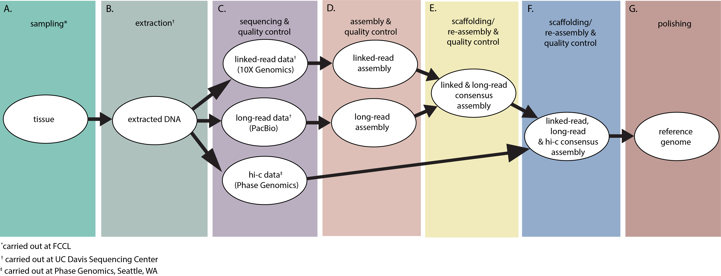

**Figure 1.** Workflow diagram for completion of assembling reference genome for delta smelt (Task 1). Both male and female delta smelt will undergo the pipeline separately to produce two reference genomes––one male and one female. All work was completed at the GVL unless otherwise noted. A.) Tissue from male and female delta smelt are sampled from the captive colony at the FCCL. B.) HMW DNA is extracted from the fish tissue samples. C.) Extracted DNA of sufficient length undergoes a library prep, subsequent sequencing and quality control for each of the three NGS technologies (linked-read, long-read and hi-c). D.) Linked- and long-read sequencing data are assembled into individual draft genomes. The draft genomes are quality assessed by the software BUSCO13. E.) The linked- and long-read assemblies are scaffolded together to produce a consensus assembly. The quality of the consensus assembly is then assessed by the software BUSCO13. F.) Hi-c data connects long-range gaps in the linked- & long-read consensus assembly. The quality of the consensus assembly is then assessed by the software BUSCO13. G.) Final polishing to produce a reference genome.

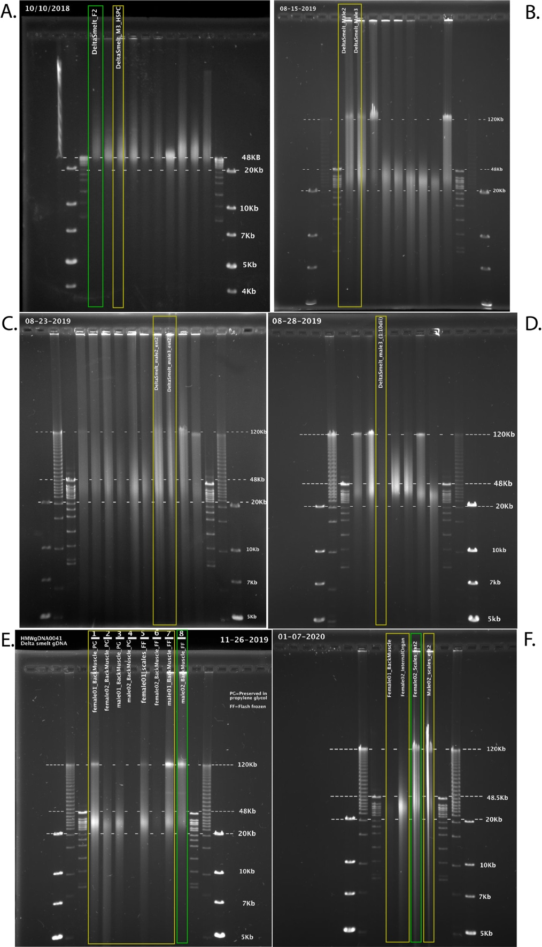

**Figure 2.** Pulse field gel images of extracted HMW gDNA from three sampling trips (“T”) and six rounds of extractions (“E”). Green boxes surround lanes from extracted samples usable for long-read and linked-read sequencing (extraction distribution centered ~ 50kb), yellow boxes surround lanes from samples with insufficient extraction lengths. A) T1, E1: one usable female sample (T1_F02) B) T2, E2: no usable samples C) T2, E3: no usable samples D) T2, E4: no usable samples (E) T3, E5: one usable male sample (T3M02_BM_FF) F) T3, E6: one usable female (T3F02_SC_FF).

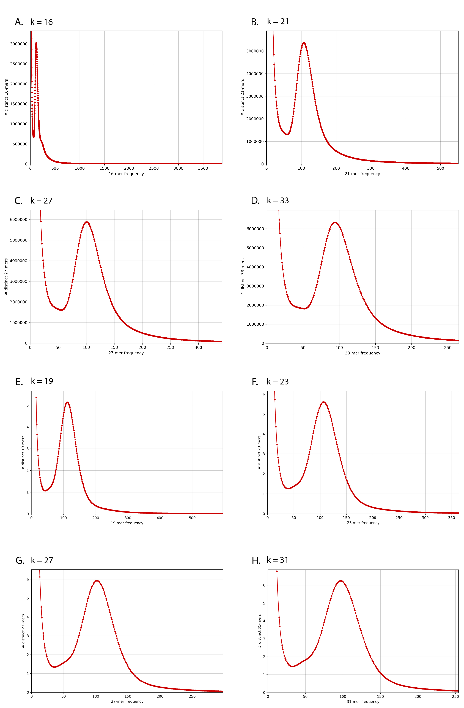

**Figure 3.** Linked-read k-mer spectra histogram of the number of distinct k-mers at different frequencies from female (A-D) and male (E-H) sequencing data. Uncontaminated samples are expected to have a single peak with a lot of k-mers at a very low frequency due to sequencer errors.

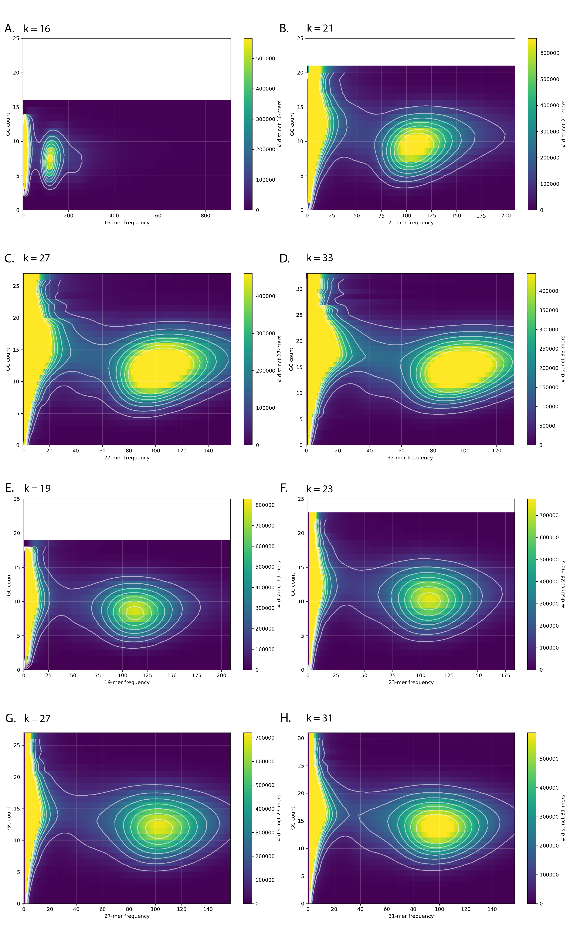

**Figure 4.** Plots of k-mer frequency (x-axis) vs GC count (y-axis) colored by the number of distinct k-mers used to detect bacterial and organelle contamination in linked-read sequence data. Blue indicate fewer distinct k-mers with a given GC count and frequency, while yellow indicates more distinct k-mers. No indication of contamination was detected in female (A-D) and male (E-H) sequencing data.

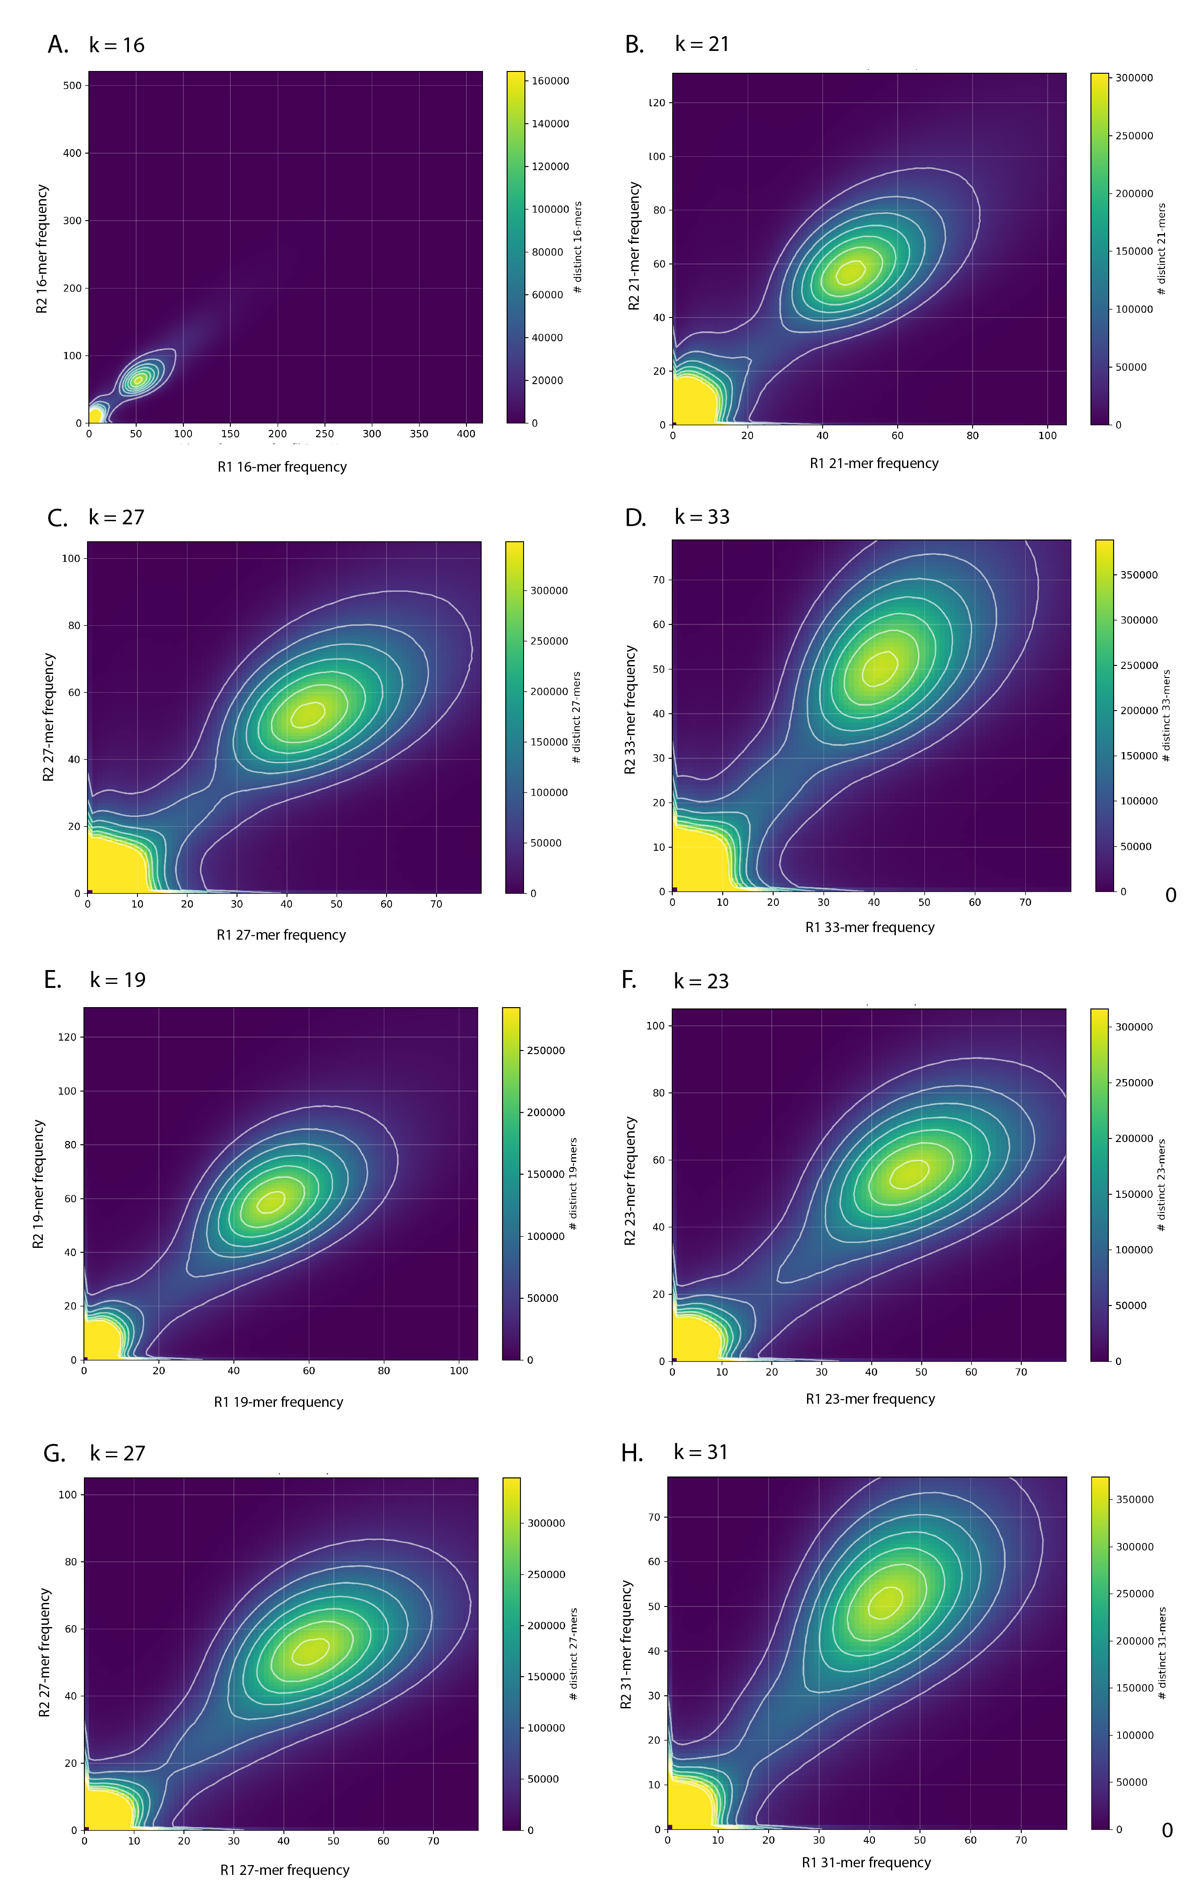

**Figure 5.** K-mer comparison plot of the number of distinct k-mers at different frequencies in linked-read sequence data from the female (A-D) or male (E-H) samples. For all plots the R1 (x-axis) and R2 (y-axis) captures a slightly different information.

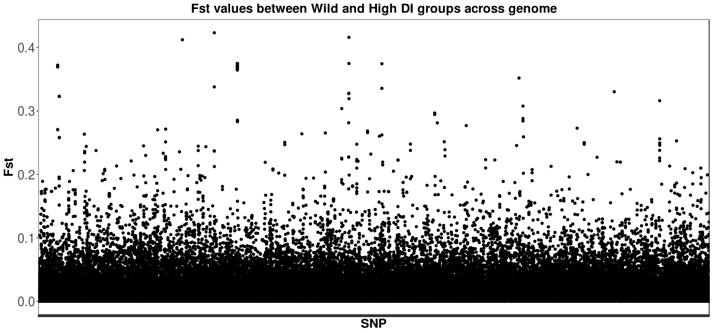

**Figure 6.** FST analysis between wild and high DI group across genome. Some genomic loci show strong differences across the genome.

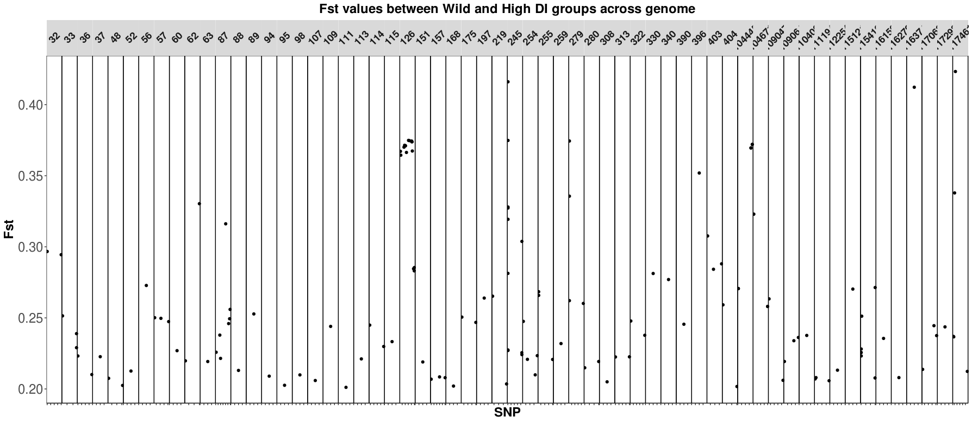

**Figure 7.** FST analysis between wild and high DI group. Only SNPs with an FST > 0.2 are shown for convenience. Scaffolds 126 and 245 (boxed in red) appear to have outlier loci (indicating genes may be under domestication selection) due to their higher FST values and more SNPs per scaffold.

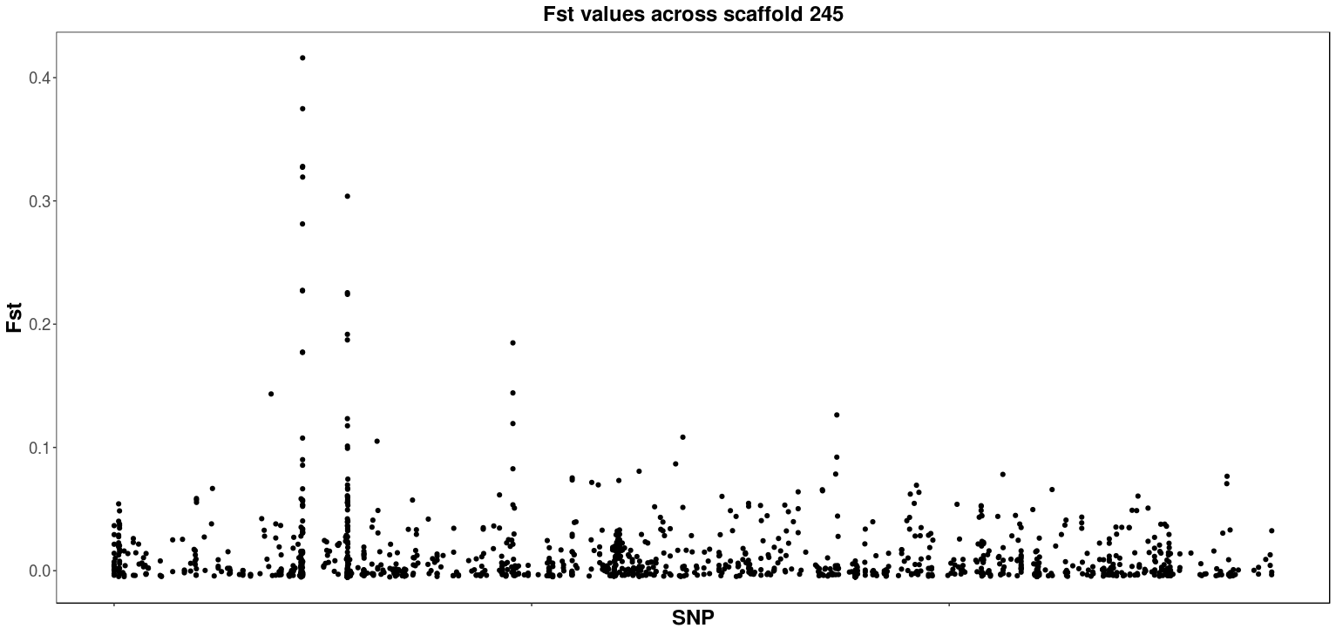

**Figure 8.** SNP distribution across scaffold 245. Outlier SNPs are clustered in one region of scaffold 245. This clustering strengthens the probability of the locus being under selection––an FST peak may be created by SNPs linked to the causative domestication variant.

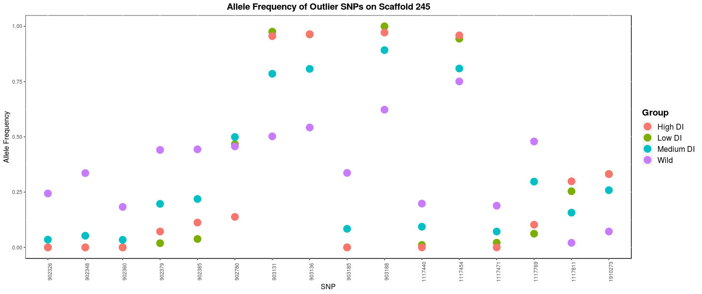

**Figure 9.** Allele frequency changes of outlier SNPs on scaffold 245 across wild, low, medium, and high DI groups. Changes in allele frequency follow the same pattern for each SNP; it either increases or decreases from the wild to high DI groups. This confirms that in all four groups, the SNPs on scaffold 245 are consistently outliers and selection is occurring in early generations in captivity.

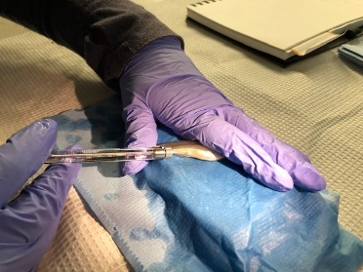

**Figure 10.** Image of colchicine injection.

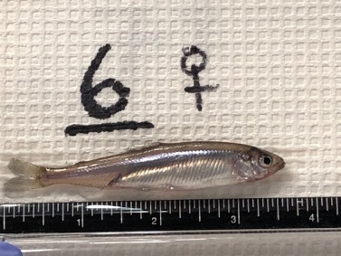

**Figure 11.** Female delta smelt, 360 days post hatch.

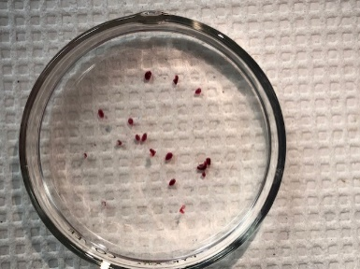

**Figure 12.** Pool of individual spleens.

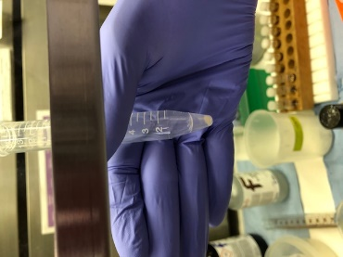

**Figure 13.** Cell pellet from pooled organs.

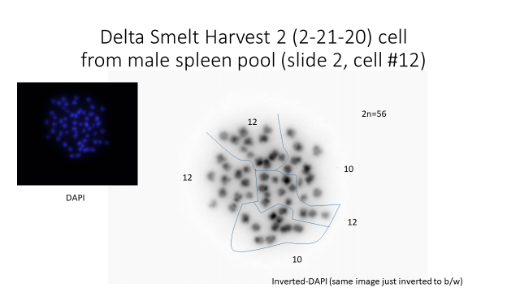

**Figure 14.** A mitotic cell (metaphase stage) from male spleen-pool, 2n = 56.

**References**

1. Allendorf FW, Hohenlohe PA, Luikart G. Genomics and the future of conservation genetics. *Nat Rev Genet*. 2010. doi:10.1038/nrg2844

2. Steiner CC, Putnam AS, Hoeck PEA, Ryder OA. Conservation Genomics of Threatened Animal Species. *Annu Rev Anim Biosci*. 2013;1(1):261-281. doi:10.1146/annurev-animal-031412-103636

3. Waples RS. Making sense of genetic estimates of effective population size. *Mol Ecol*. 2016;25(19):4689-4691. doi:10.1111/mec.13814

4. Prince DJ, Rourke SMO, Thompson TQ, et al. The evolutionary basis of premature migration in Pacific salmon highlights the utility of genomics for informing conservation. *Sci Adv*. 2017;3(August). doi:10.1126/sciadv.1603198

5. Narum SR, Genova A Di, Micheletti SJ, Maass A. Genomic variation underlying complex life-history traits revealed by genome sequencing in Chinook salmon. *Proc R Soc B Biol Sci*. 2018;285(1883).

6. Rhie A, McCarthy SA, Fedrigo O, et al. Towards complete and error-free genome assemblies of all vertebrate species. *bioRxiv*. January 2020:2020.05.22.110833. doi:10.1101/2020.05.22.110833

7. Wasko AP, Martins C, Oliveira C, Foresti F. Non-destructive genetic sampling in fish. An improved method for DNA extraction from fish fins and scales. *Hereditas*. 2003;138(3):161-165. doi:10.1034/j.1601-5223.2003.01503.x

8. Mapleson D, Accinelli GG, Kettleborough G, Wright J, Clavijo BJ. Sequence analysis KAT : a K-mer analysis toolkit to quality control NGS datasets and genome assemblies. 2017;33(November 2016):574-576. doi:10.1093/bioinformatics/btw663

9. Nurk S, Walenz BP, Rhie A, et al. HiCanu : accurate assembly of segmental duplications , satellites , and allelic variants from high-fidelity long reads. *bioRxiv*. 2020:1-31. doi:https://doi.org/10.1101/2020.03.14.992248

10. Ali OA, O’Rourke SM, Amish SJ, et al. Rad capture (Rapture): Flexible and efficient sequence-based genotyping. *Genetics*. 2016;202(2):389-400. doi:10.1534/genetics.115.183665

11. Li H, Handsaker B, Wysoker A, et al. The Sequence Alignment/Map format and SAMtools. *Bioinformatics*. 2009;25(16):2078-2079. doi:10.1093/bioinformatics/btp352

12. Korneliussen TS, Albrechtsen A, Nielsen R. ANGSD: Analysis of Next Generation Sequencing Data. *BMC Bioinformatics*. 2014;15(1):1-13. doi:10.1186/s12859-014-0356-4

13. Simão FA, Waterhouse RM, Ioannidis P, Kriventseva E V., Zdobnov EM. BUSCO: Assessing genome assembly and annotation completeness with single-copy orthologs. *Bioinformatics*. 2015;31(19):3210-3212. doi:10.1093/bioinformatics/btv351